Build A Function (grade 8) Name _____________________________

- Build a function which meets the following criteria.
- The function is continuous.
- The function is non-linear.
- The function has a maximum.
- The function continually decreases.
- The function has a y-intercept.

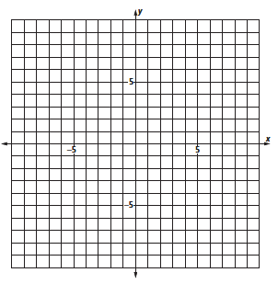

- Create a scenario, or story, modeled by your function.

__________________________________________________________________________________
__________________________________________________________________________________
__________________________________________________________________________________
__________________________________________________________________________________
__________________________________________________________________________________
__________________________________________________________________________________

Build A Function (grade 7) Name _____________________________

- Build a function which meets the following criteria.
- The function is discrete.
- The function is non-linear.
- The function has a maximum and a minimum.
- The function continually decreases.
- The function has no intercepts.

- Create a scenario, or story, modeled by your function.

__________________________________________________________________________________
__________________________________________________________________________________
__________________________________________________________________________________
__________________________________________________________________________________
__________________________________________________________________________________
__________________________________________________________________________________

