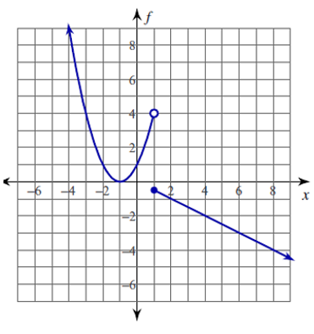
- (Skill) Use the graph of f(x) shown below to answer the following questions.

- What is the value of f(1)?

- What is the interval where the graph is increasing?

- (Application) Describe the graph of the weight of a puppy on the day it was born until he was 2 years old. Describe the real world meaning of the vertical intercept of the graph.

- (Application) Sketch what you think is a reasonable graph for snow accumulation in New York measured monthly from January through June. Identify the variables and label your axes appropriately.

