Name: ____________________
Date: _______________
A2: Measuring and Constructing Segments

Objectives: | Use length and midpoint of a segment.  Construct midpoints and congruent segments.
Develop the Segment Addition Postulate: | 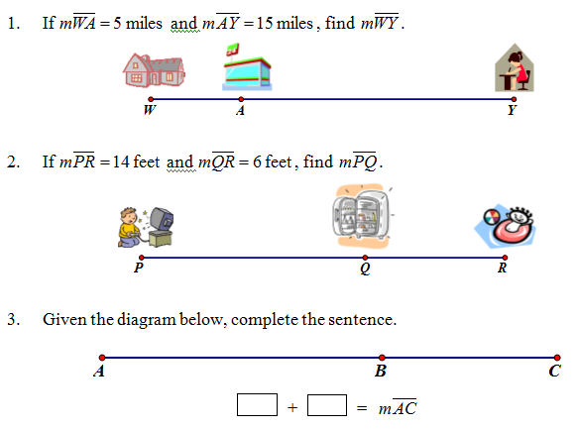
Segment Addition Postulate: | Postulate: If B is between A and C, then AB + BC = AC.
Example 3: | - B is between A and C, AC=14, and BC=11.4. Find AB.  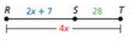  - S is between R and T. Find RT.  - B is the midpoint of AC. AB=5x and BC=3x+4. Find AB, BC, and AC.
Compare and Contrast: | B is between A and C. B is the midpoint of $\overline{AC}$.  Sketch  Equation
Challenge Questions: | - HJ is twice JK. J is between H and K. If HJ = 4x and HK = 78, find JK.  - A, D, N, and X are collinear points. D is between N and A. NA + AX = NX. Draw and diagram that represents this information.  - Given that J, K, and L are collinear and that K is between J and L, is it possible that JK = JL? If so, draw an example. If not, explain.

