Task: See task sheet
Standard(s) and Pre-Task Activity Suggestions:
- 7.NS – Apply and extend previous understandings of operations with fractions to add, subtract, multiply an divide rational numbers

Instruction:
Ask students to generate a list of things to consider that go into planning a field trip. List student responses on the board (bus, tickets, chaperones, etc). Next, have the students read the task. Students should connect information from the task to the list they generated on the board.
Have the students begin to answer question # 1. Ask the students how they would organize the student survey results. Work with students to develop a tally-chart and have students record the data. Facilitate a discussion of which place should be chosen solely based on student votes. Elicit reasoning for why each place could be chosen. For space, consider using a weighted scale that assigns more value to first choice vs. second choice. As a reference, project the results of 2016’s MLB Manager of the Year voting.
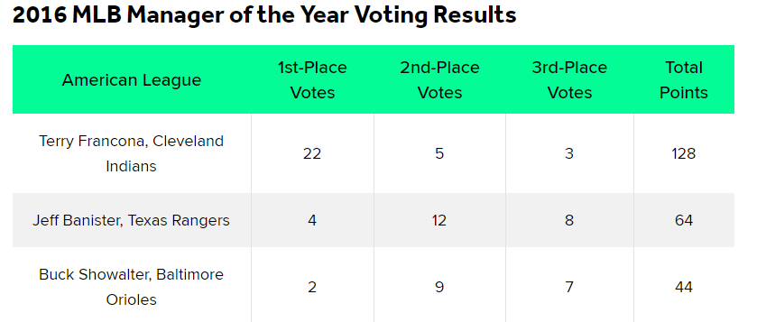
Ask the students to analyze the chart to determine how the “total points” column was calculated. Use this example to lead the students to create a point system to analyze the field trip survey results. For example, in the chart above, 1st place gets 5 points, 2nd place gets 3 points, and 3rd place gets 1 point.
Give the students time to analyze the survey results and decide on a location for the field trip. Have students move to a spot in the room based on their choice. Within this group, students should explain their reasoning.
Have the students work in their group to find the cost per student for the trip they chose (question # 2). Have some students show their work on chart paper or the document projector to explain their calculations. As students present their solutions, ask groups if they considered the round-trip mileage when calculating the cost for the field trip.

