# | Brain Break | Materials
1 | Pencil Bounce/Speed Eraser  Throw pencils so that they land on their eraser end, bounce and land in a cup or container | 1 bucket per group; 5-10 pencils per group (unsharpened)
2 | Mystery Number  Pick a three digit number and have students ask yes or no questions to guess the number. Give students 20 questions to guess the number and the winner gets to pick the next secret number. | None
3 | Face the Cookie  Move two cookies from their forehead to their mouth using only their face muscles. | 1 package of Oreo cookies
4 | Keep It Up  Keep feathers off of the ground by blowing them up in the air. | 1 feather for each kid
5 | Gotcha  In a circle, the goal is to grab one person’s finger on one side of you and avoid your finger getting captured by the person next to see. See video. | None
6 | Noggle  Students can use addition, subtraction, multiplication, division, and/or parentheses in the expressions they write that have the given answer. They have 3 minutes to write as many expressions as possible. | Noggle board (see resources), whiteboards or paper
7 | Rebus Puzzles  Provide picture puzzles for students to guess the word or phrase that is shown. | Rebus puzzles (see resources)
8 | Charades  Play charades in groups or teams. A team volunteer silently acts out the clue with no words or sounds as team members guess in 60 seconds or less. | Charade cards (see resources)
9 | The Wright Family  Students stand in groups of 3 or 4 with 1 writing utensil and listen to the Wright Family story. When the word “left” is heard, pass to the left and when the word “right” is heard, pass to the right. Recite the story slowly at first and then pick up speed. | 1 writing utensil per student  Wright Family Story (see resources)
10 | Optical Illusions  Provide optical illusion puzzles for students to guess what they see shown in the pictures. | Optical Illusion puzzles (see resources)
11 | Logic Puzzles  Share several logic puzzles for students to try and correctly answer. | Logic puzzles (see resources)
12 | Riddles  Share several riddles for students to try and correctly answer. | Riddles (see resources)
13 | Floyd’s Knob Puzzle  Provide the Floyd’s Knob town puzzle and have students determine the correct solution. | Floyd’s Knob (see resources)
14 | Four Corners  Students quickly go to a corner of their choice. Teacher generates a number from 1 – 4 and students at the selected corner are out (sit down). Students move to another corner and repeat until there is 1 student left (the winner). | 1 random number generator  4 labeled corners
15 | Line Ups  Give students 1 minute to line themselves up based on height, age, birthday, shoe size, alphabetically by middle name, etc… Use a timer to see how fast they can do it OR have them try it silently! | None
16 | Class Counts  As a class count from 1 – 10 (or try the alphabet). Only one person can talk at a time and if two people say a number, then you must start over. Try to accomplish this as fast as possible! | None
17 | Freeze Dance  Dance around the room until the music stops and freeze when the music stops. You must hold the freeze until the music starts again. | Music
18 | Caddy Stack  Build a tower of 3 golf balls that must remain standing for 3 seconds. | 3 golf balls per group
19 | Defying Gravity  Keep three balloons in the air for 60 seconds using ninja like reflexes. | 3 party balloons per group
20 | Separation Anxiety  Sort a pack of M&M’s in order by color using only one hand. | 1 package of M&M’s per group  6 cups per group
21 | Bridging the Gap  Using one deck of cards, build a bridge between two books placing the empty box in the middle. | 1 deck of cards per group  2 books per group
22 | Trading Places  Six volunteers line up in order horizontally (see image to the right). You can slide one space or jump one space. The goal is for all students from one side to get to the other side in the least amount of moves. | 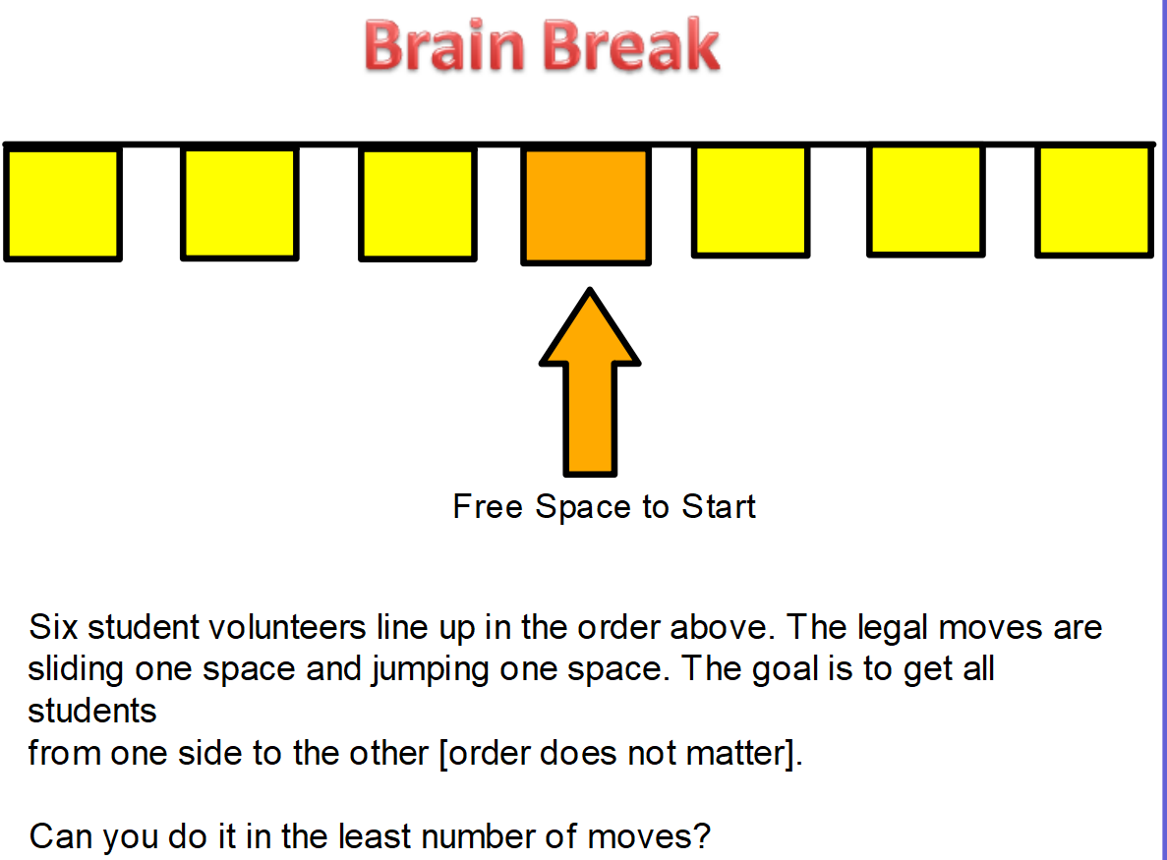

Other Easy and Fun Brain Breaks:
- Simon Says
- Win, Lose or Draw/Pictionary
- Hang Man
- Mad Libs
- Mad Gabs
- Tic-Tac-Toe
- The Game of NIM
- Heads Up 7UP

