Reflecting and Evaluating:
Students should be tasked with completing the table below based on their learning:
Function | Family | Domain | Even/Odd/Neither | End Behavior | Number of Zeros | Asymptotes
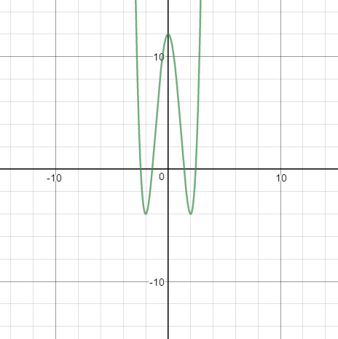 | Quartic (x^4)  Similar to Quadratic | Negative infinity to Infinity | Even | As x approaches negative Infinity y approaches positive infinity, As x approaches positive Infinity y approaches positive infinity. | Four | No
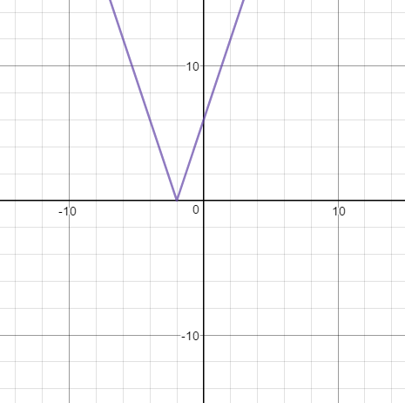 | Absolute Value | Negative infinity to Infinity | Neither (looks even but not symmetric to y-axis) | As x approaches negative Infinity y approaches positive infinity, As x approaches positive Infinity y approaches positive infinity. | One | No
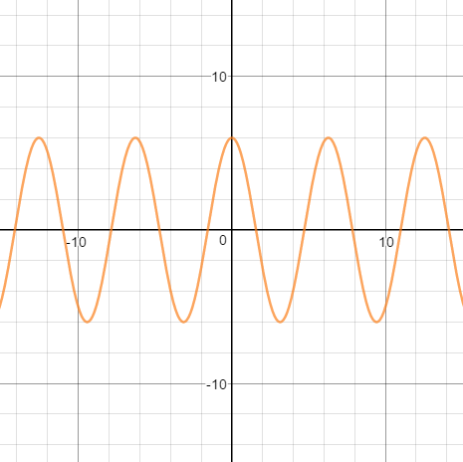 | Sinusoidal | Negative infinity to Infinity | Even | N/A (for now) | Infinite | No
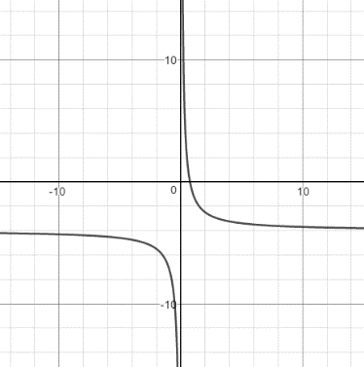 | Rational | Negative infinity to zero and zero to Infinity | Neither | N/A (for now) | One | Yes

