Task 1 NAME:
Empirical Rule WS

Given an approximately normal distribution with a mean of 175 and a standard deviation of 37. Draw the normal curve.

a) What percent of values are within the interval (138, 212)?

b) What percent of values are within the interval (101, 249)?

c) What percent of values are within the interval (64, 286)?

d) What percent of values outside the interval (138, 212)?

e) What percent of values are outside the interval (101, 249)?

f) What percent of values are outside the interval (64, 212)?

Task 2 NAME:
Empirical Rule WS

Given an approximately normal distribution with a mean of 121 and a standard deviation of 40.

a) Draw a normal curve and label 1, 2, and 3 standard deviations on both sides on the mean.

b) What interval contains 68% of all values?

c) What interval contains 95% of all values?

d) What interval contains 99.7% of all values?

e) What percent of values are above 201?

f) What percent of values are below 81?

Task 3 NAME:
Empirical Rule WS

Given an approximately normal distribution with a mean of 159 and a standard deviation of 70. Draw and label the bell curve.

a) What percent of values are within the interval (89, 299)?

b) What percent of values are within the interval (19, 159)?

c) What interval contains 99.7% of all values?

d) What percent of values are above 229?

e) What percent of values are outside the interval (19, 229)?

Task 4 NAME:
Empirical Rule WS

The heights of male students is normally distributed with a mean of 170 cm and a standard deviation of 8 cm. Find the percentage of male students whose height is: (Draw and label a bell curve)

  - between 162 cm and 170 cm b) between 170 cm and 186 cm

c) between 178 cm and 186 cm d) less than 162 cm

e) less than 154 cm f) greater than 162 cm

Task 5 NAME:
Empirical Rule WS

It is known that when a specific type of radish is grown in a certain manner without fertilizer the weights of the radishes produced are normally distributed with a mean of 40g and a standard deviation of 10g. When the same type of radish is grown in the same way except for the inclusion of fertilizer, it is known that the weights of the radishes produced are normally distributed with a mean of 140g and a standard deviation of 40g. Determine the proportion of radishes grown: (Draw the distributions)

a) Without fertilizer with weights less than 50 grams.

b) With fertilizer with weights less than 60 grams.

c) With and without fertilizer with weights between 20 and 60 grams.

d) With and without fertilizer that will have weights greater than or equal to 60 grams.

Task 6 NAME:
Empirical Rule WS

500 juniors at Central High School took the ACT last year. The scores were distributed normally with a mean of 22 and a standard deviation of 3. Label the mean and three standard deviations from the mean.
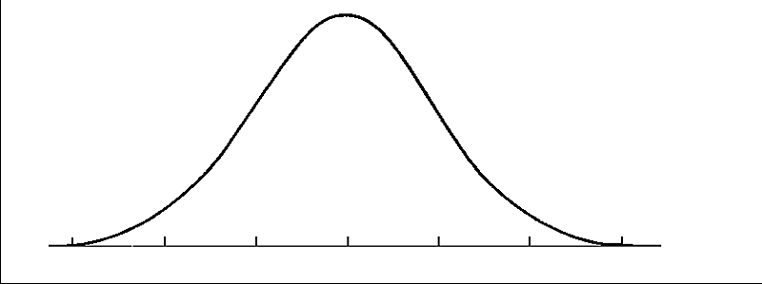
Answer the following questions based on the data:
a) What percentage of scores are between scores 16 and 28?

b) What percentage of scores are between scores 19 and 22?

c) What percentage of scores are between scores 16 and 25?

d) What percentage of scores is less than a score of 13?

e) What percentage of scores is greater than a score of 25?

Task 7 NAME:
Empirical Rule WS
2000 freshmen at State University took a biology test. The scores were distributed normally with a mean of 70 and a standard deviation of 5. Label the mean and three standard deviations from the mean.
Answer the following questions based on the data:
a) What percentage of scores are between scores 65 and 75?

b) What percentage of scores are between scores 60 and 70?

c) What percentage of scores are between scores 60 and 85?

d) What percentage of scores is less than a score of 55?

e) What percentage of scores is greater than a score of 80?

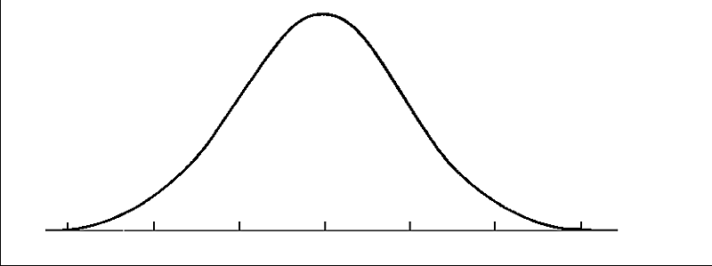

Task 8 NAME:
Empirical Rule WS
500 juniors at Central High School took the ACT last year. The scores were distributed normally with a mean of 24 and a standard deviation of 4. Label the mean and three standard deviations from the mean.
Answer the following questions based on the data:
a) What percentage of scores are between scores 20 and 28?

b) What percentage of scores are between scores 16 and 32?

c) What percentage of scores are between scores 16 and 28?

d) What percentage of scores is less than a score of 12?

e) What percentage of scores is greater than a score of 24?

Task 9 NAME:
Empirical Rule WS
500 freshmen at Schaumburg High School took an algebra test. The scores were distributed normally with a mean of 75 and a standard deviation of 7. Label the mean and three standard deviations from the mean.
Answer the following questions based on the data:
a) What percentage of scores are between scores 61 and 82?

b) What percentage of scores are between scores 75 and 82?

c) What percentage of scores are between scores 61 and 89?

d) What percentage of scores is less than a score of 61?

e) What percentage of scores is greater than a score of 96?

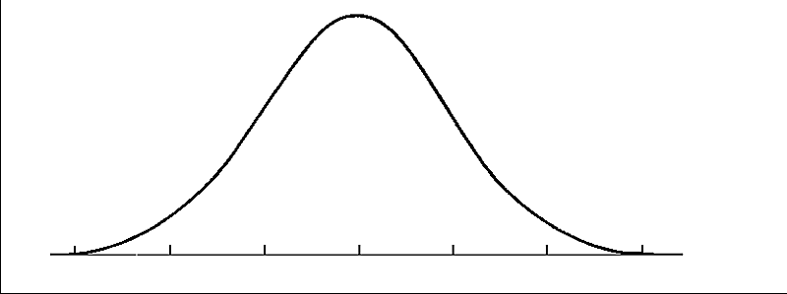

Task 10 NAME:
Empirical Rule WS
500 freshmen at Stats High School took an algebra test. The scores were distributed normally with a mean of 83 and a standard deviation of 4. Label the mean and three standard deviations from the mean.
Answer the following questions based on the data:
a) What percentage of scores are between scores 75 and 83?

b) What percentage of scores are between scores 71 and 87?

c) What percentage of scores are between scores 71 and 95?

d) What percentage of scores is less than a score of 79?

e) What percentage of scores is greater than a score of 91?
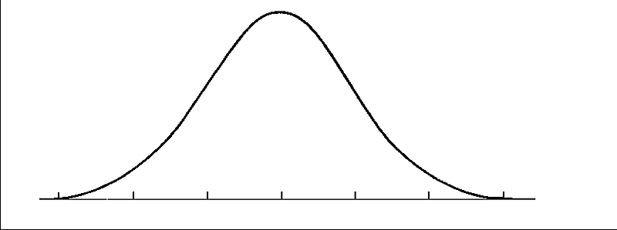

Task 11 NAME:
Empirical Rule WS
The scores for all high school seniors at Pope taking the verbal section of the Scholastic Aptitude Test (SAT) in a particular year had a mean of 490 and a standard deviation of 100. The distribution of SAT scores is bell-shaped and normally distributed. Draw the normal bell curve to support your answers.

What percentage of seniors scored between 390 and 590 on this SAT test?

One student scored 795 on this test. How did this student do compared to the rest of the scores?

A rather exclusive university only admits students who were among the highest 16% of the scores on this test. What score would a student need on this test to be qualified for admittance to this university?

The senior class at Pope has 450 students and offers a $500 scholarship to everyone that gets above a 690 on the test. What percent of students does Pope have to give the scholarship to?

Task 12 NAME:
Empirical Rule WS

All the data is normally distributed. Draw each bell curves to represent the problem stated, and answer any questions.
What percent of seniors boys have the height between 57 and 71 inches? The mean of the data is 64 inches with a standard deviation of 7inches.

Collected data on the cost of computers at Best buy shows that 95% of the prices are between what two values? The mean of the data is $750 with a standard deviation of $125.

Collected data on the number of points scored at the basketball games for the 2010 Greyhound season shows that 99.7% of the scores fall within what interval? The mean is 100 points with a standard deviation of 14 points.

Collected data on the number of text messages sent by a group of 100 random high school students shows that 68% of high school students send between what interval? The mean is 520 with a standard deviation of 20.

Task 13 NAME:
Empirical Rule WS

The scores for all high school seniors taking the verbal section of the Scholastic Aptitude Test (SAT) in a particular year had a mean of 490 and a standard deviation of 100. The distribution of SAT scores is bell-shaped. Draw the normal bell curve to show the distribution.

- What percentage of seniors scored between 390 and 590 on this SAT test?

- Determine the interval of scores that 95% of scores lie in.

- One student scored 795 on this test. How did this student do compared to the rest of the scores?

- A rather exclusive university only admits students who were among the highest 16% of the scores on this test. What score would a student need on this test to be qualified for admittance to this university?

- What percent of scores fall within the interval: (290,390)

Task 14 NAME:
Empirical Rule WS
200 freshmen at North Springs High School took an algebra test. The scores were distributed normally with a mean of 73 and a standard deviation of 8. Label the mean and three standard deviations from the mean.
Answer the following questions based on the data:
a) What percentage of scores are between scores 65 and 81?

b) What percentage of scores are between scores 49 and 97?

c) What percentage of scores are between scores 57 and 89?

d) What percentage of scores is less than a score of 57?

e) What percentage of scores is greater than a score of 97?

