Math 133

Final Exam

Name:

1. Find the mean and median for this set of numbers as well as the 5 number summary, IQR and determine if there are any outliers.

{2, 4, 5, 6, 6, 7, 9, 10, 12, 13, 14, 16, 16, 18, 30}





2. What is the probability that if you flip a coin 20 times you get 9 tails?
3. What is the probability that if you roll a 6-sided die you do not get you first 5 until your 8th roll?
4. If you have a bag with 4 red marbles, 3 blue, 5 green and 3 orange. What is the probability that you flip a coin and get tails and then select a blue marble?
5. John scores a 78 on his Statistics test where the class average was a 70 with a standard deviation of 6 and then he scored an 82 on his English test where the class average was a 78 but the standard deviation was 3.
6. Using Z-Scores explain which test he did better on compared to the rest of his class.

b) What percent of the class scored higher then John in his Statistics class?

c) What percentage of his English class scored lower than he did?

d) Approximately what percent of his English class scored between 75 and 81?

1. What type of correlation is show in the scatterplot below and approximate the value of

“r”? Also if the x-axis is AGE and the y-axis is Height, what is this graph telling us?

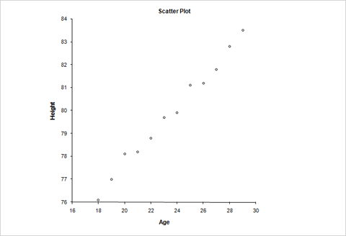

1. The table below gives the number of hours spent studying for a science exam (x) and the final exam grade (y).

|  |  |  |  |  |  |  |  |
| --- | --- | --- | --- | --- | --- | --- | --- |
| X | 2 | 5 | 1 | 0 | 4 | 2 | 3 |
| Y | 77 | 92 | 70 | 63 | 90 | 75 | 84 |

1. What is the equation for the line of best fit?
2. What is the value of the slope and what does that mean in the context of the problem?
3. If you were to study for 3.5 hours what would we predict our final exam score to be?
4. If you have two points (-2, 5) and (1, -4) what would be the equation of a line that passes through those two points?
5. What would be the equation of a line perpendicular to the line in problem #10 that passes through the point (9, 12)?
6. Solve the equation |2x – 4|= 10
${Solve this equation by factoring 4x}^{2}+12x-40=0$

7. Solve this equation using any method: $6x^{2}-11x-8=2$
8. Solve this Inequality and graph the solution: $\left|\frac{x}{3}+4\right|≥8$

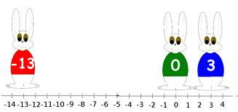

1. What is the Domain and Range of this Relation? {(2, 3), (4, 5) (5, 8), (6, 8) (9, 10)}
2. Is the relation in #16 a function? What is the inverse of that relation and is that a function?
3. Find the inverse of the function: f(x) = 2x – ½
4. Given the two functions:  

Find the value of (f + g)(x) and the value of $\left(f∙g\right)(x)$

1. Using the same two functions evaluate $\left(f o g\right)(-2)$
2. Show that these two functions are or are not inverses. (Any method)

 

1. Solve the equations below involving logs and exponents:
$\log_{2}\left(3x+2\right)=6$

2. $4^{2x-4}$ =1024
3. Expand the following expression using the rules of logs: $\log_{2}\frac{x^{2}y^{3}}{w^{4}}$
4. What is the degrees of the monomial $4w^{3}x^{2}y^{3}z$?
5. If the zeros of a cubic polynomial are -2, 1, and 3 what is the expression that represents this function?