Geometry Note Sheet DAY 2 Date: _____________________

- What does it mean for lines/segments to be perpendicular?

- Construction of a perpendicular bisector. (Laser Problem)
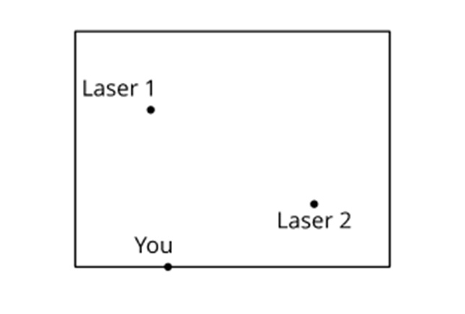
Definitions:
- Conjecture: ____________________________________________________________________

______________________________________________________________________________

- Line Segment: __________________________________________________________________

______________________________________________________________________________

- Parallel: _______________________________________________________________________

______________________________________________________________________________

- Perpendicular Bisector: __________________________________________________________

______________________________________________________________________________

