Try It: Unit 1 Lesson 2
Directions: Fill in the table. The first one is done for you as an example.
 | Value of the zero(s) | Value of the y-intercept(s) | Identify the interval(s) where the function is negative | Identify the interval(s) where the function is positive
Example: 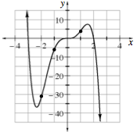 | -3, 0, 2 | 0 | $$-3<x<0$$  $$2<x<∞$$ | $$-∞<x<-3$$  $$0<x<2$$
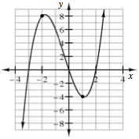
1.

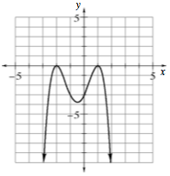
2.
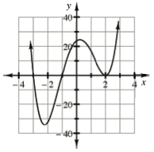
3.

x | y
-4 | 1
-3 | 0
-2 | -1
-1 | -2
0 | -3
1 | -2
2 | -1
3 | 0
4 | 1
4. Answer based on the continuous function that is given in this table:

