Practice B
LESSON
6-2
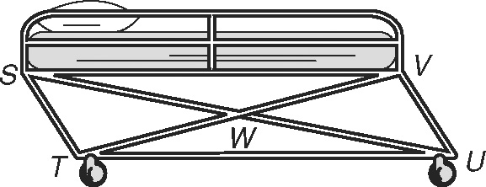
Properties of Parallelograms
A gurney is a wheeled cot or stretcher used in hospitals.
Many gurneys are made so that the base will fold up for
easy storage in an ambulance. When partially folded, the
base forms a parallelogram. In STUV, VU = 91 centimeters,
UW = 108.8 centimeters, and m∠TSV = 57°. Find each measure.
1. SW 2. TS 3. US

4. m∠SVU 5. m∠STU 6. m∠TUV

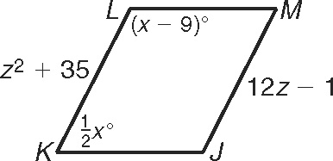
JKLM is a parallelogram. Find each measure.

7. m∠L 8. m∠K 9. MJ

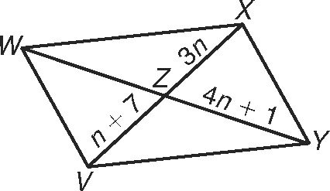
VWXY is a parallelogram. Find each measure.
10. VX 11. XZ

12. ZW 13. WY

14. Three vertices of ABCD are B(−3, 3), C(2, 7), and D(5, 1).
Find the coordinates of vertex A. _____________________
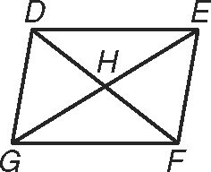
Write a two-column proof.

15. Given: DEFG is a parallelogram.
Prove: m∠DHG = m∠EDH  m∠FGH

