Why Should I do WELL in Pre-College Mathematics
As we have discussed, each and every one of you can gain credit for CCBC’s remedial math courses if you successfully complete this course with a B average and at least a 70% on the final. Even if you are not going to CCBC, you can still place into a higher mathematics course at the school of your choice. Some of you may say “I don’t care,” ”I’ll worry about that when I need to…” Well, guess what – Now is the time!
For this project, you and your group (no more than 3 per group!!) will compare the cost of courses at CCBC to TWO different 4 year colleges of your choice. Please follow all guidelines and make sure to be as thorough as possible. You will be required to type this information up to be turned in, as well as put this information on poster paper to hang in the classroom.
You are basing this project on if you had to take all 3 remedial math courses and must include the information below. You can find CCBC’s information on their website at www.ccbcmd.edu :
**Remember, these remedial courses are a non-credit bearing which means that you cannot take any math course towards your degree until you successfully complete these courses.
- Pick TWO other 4 year colleges either in the state of Maryland or somewhere else you have in mind. You must get your two school choice approved by __________________
- Research on CCBC’s website how much 1 remedial course cost. The math remedial courses are Math 081, Math 082 and Math 083. Remember, each course is 3 billable hour. How much will all 3 courses cost you?
- Research on CCBC’s website how much the textbook cost for each course. How much will you spend total.
  - Here’s some help: http://www.bookstore.ccbcmd.edu/dundalk/
    - You must generate a booklist and do the cost of each book individually for Math 081, Math 082 and Math 083.
- How many hours total will you spend in these courses? Remember each course meets twice a week for a total of 3 hours. Research how many weeks the course will run for, how many hours total will you be sitting in class for each course. How many hours total for all remedial courses?
- Students are told that on average they should be spending 6-8 hours at home, per week, on studying and homework. How many hours of YOUR time will you be spending for each course? Total for all remedial courses?
- How much time and money will you save if you only have to take 2 remedial courses? 1 course? None?
- Research how much 1 year at the two colleges of your choice cost.
  - Include textbooks if possible!
- Grab a piece of poster paper/markers and make a beautiful poster with this information that we can decorate the room with
**You may choose to email me your typed project at ________________________ or print it out.

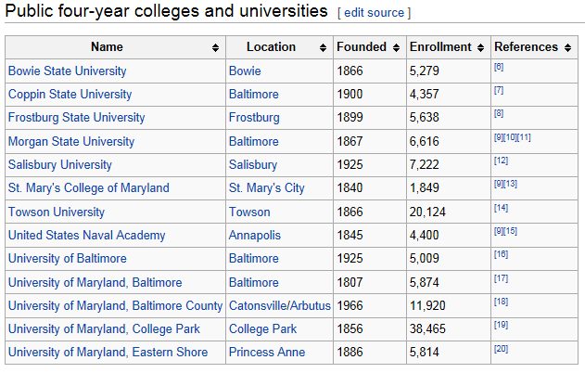
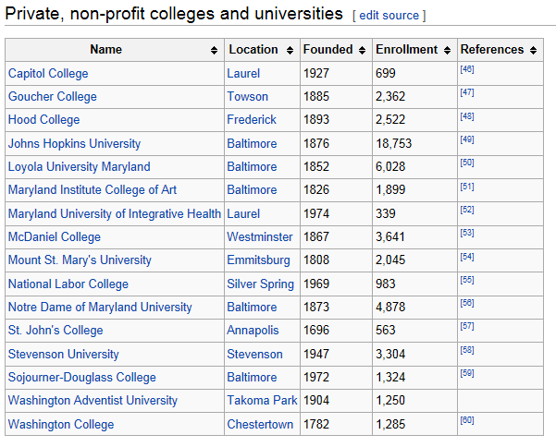

Due: _____________________________
- GROUP COLLABORATION – Create a poster to display in our room comparing a math course at the community college versus a four-year institution. Include cost, time, and other interesting facts. * One suggested format.
CCBC  (Locations) | One  PreReq  Course  MATH081 | Two  PreReq  Courses  MATH082 | Three  PreReq  Courses  MATH083 | Total of All  Three Categories
CONTENT COVERED

Tuition Cost
Book Cost
Fees (if applicable)
TOTAL COST
Total Hours in Class
Total Hours of Your Time
TOTAL HOURS
*Write a short summary of the pro / con comparison of entering CCBC without needing to complete prerequisite course work, including time and money commitments.
 | (College #1)  Location | (College #2)  Location
Tuition & Fee cost of one
course
Book Cost (if applicable)

SAT Score for Admission

GPA for Admission

- PERSONAL REFLECTION – Write a short one page, typed 12 font, 1 inch margin paper letting me know a little about yourself and your intentions for post high school life. In a coherent format, include prior math experiences, areas of difficulty, and what you hope to improve mathematically or personally this year. Also include your current intent in your post high adventure. Consider the following questions. Are you going to college? Two year or four year? If you are going to a four year college, do you know where you are applying? Are you going to the military? Are you going right into the work place? Will you need training for the work place? Are you unsure what is going to happen after high school? Is here anything else that you would like to share or help you need from me this year?

PRECOLLEGE MATH: RESEARCH SUPPORT

Why did I need to get a plan?
http://youcango.collegeboard.org/

CCBC Resources
Tuition and Fees
http://www.ccbcmd.edu/costs-and-paying-for-college/tuition-and-fees
Compare Costs – *go to the bottom for part time student rates
http://www.ccbcmd.edu/Costs-and-Paying-for-College/Tuition-and-fees/Compare-Costs.aspx
Book Prices – generate a book list for MATH081, MATH082, and MATH083 (any section) to calculate price
http://www.bookstore.ccbcmd.edu/dundalk/default.asp?
Placement Testing
http://www.ccbcmd.edu/Get-Started/Placement-Testing.aspx
Policies regarding Developmental coursework
http://www.ccbcmd.edu/Programs-and-Courses/Developmental-Education/Developmental-Education-Policies.aspx
General Why Information
https://bigfuture.collegeboard.org/find-colleges/how-to-find-your-college-fit/community-college-faqs
http://collegelife.about.com/od/academiclife/a/6FinancialBenefitsOfACollegeDegree.htm

Date ____________ Title of Work _____________________________ Name ____________________
Poster Board Rubric
Criteria
 | 4 | 6 | 8 | 10 | Points
Accurate Information on Worksheets | No information was given. | Some information was given. | Accurate information was given. | Additional information was given.
Written Presentation of Display | Nothing was shared. Work was not completed. | Most of the presentation was complete, but a little disorganized in presenting. | Good presentation. Information was complete. | Exceptional presentation. Complete information.
 |  |  |  | TOTAL = 20 pts

