Name

Class

Date



**Extra Practice**

Chapter 7

**Lesson 7-1**

**Solve each proportion.**

**1. ** **2. ** **3. **

**4. ** **5. ** **6. **

**7. ** **8. ** **9. **

**10.** The measures of two complementary angles are in the ratio 7 : 11. What is the measure of the smaller angle?

**Lesson 7-2**

**The polygons are similar. Find the values of the variables.**

**11.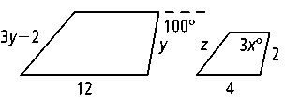 12.**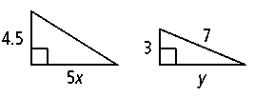

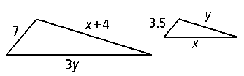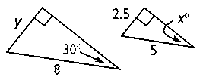**13. 14.**

**15.** Are all equilateral quadrilaterals similar? Make a sketch to support your answer.

**Lesson 7-3**

**Can you prove that the triangles are similar? If so, write a similarity statement and tell whether you would use AA ~, SAS ~ , or SSS ~.**

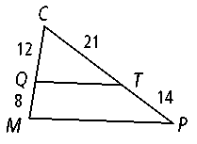**16. 17.**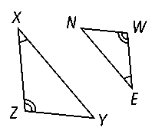

**Prentice Hall Geometry •** Extra Practice

Copyright © by Pearson Education, Inc., or its affiliates. All Rights Reserved.

**23**

Name

Class

Date

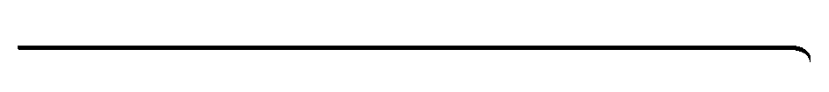

**Extra Practice** (continued)

Chapter 7

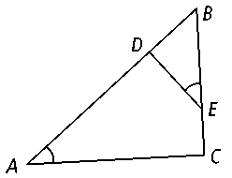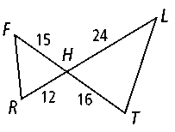**18. 19.**

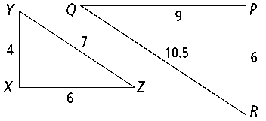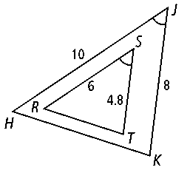**20. 21.**

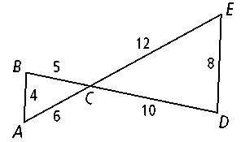**22.** Refer to the figure at the right. Explain how you know that **.

**23.** You want to determine the height of your school building. The building casts a 6-foot shadow at the same time you cast a 15-inch shadow. If you are 5 feet tall, how tall is the school building?

**Lesson 7-4**

**Find the geometric mean for each pair of numbers.**

**24.** 9 and 16 **25.** 5 and 80 **26.** 8 and 32

**Find the value of each variable. If an answer is not a whole number, leave it in simplest radical form.**

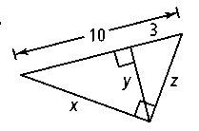**27.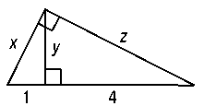 28.**

**Prentice Hall Geometry •** Extra Practice

Copyright © by Pearson Education, Inc., or its affiliates. All Rights Reserved.

**24**

Name

Class

Date

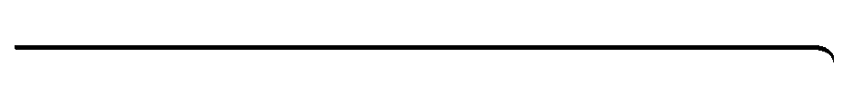

**Extra Practice** (continued)

Chapter 7

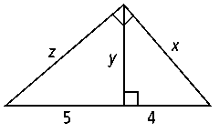**29.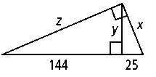 30.**

**31.** Give a coordinate proof of the converse of Corollary 1 to Theorem 7-3. That is, prove that if  is the altitude from *C* to side  of ∆*ABC*, and if *CD* is the geometric mean of *AD* and *DB*, then ∆*ABC* is a right triangle with its right angle at *C*.

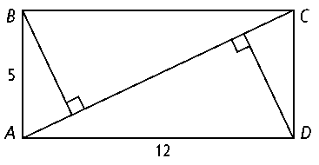**32.** An artist is going to cut four similar right triangles from a rectangular piece of paper like the one shown to the right. What is the distance from *B* and *D* to the diagonal ?

**Lesson 7-5**

**Find the value of *x*.**

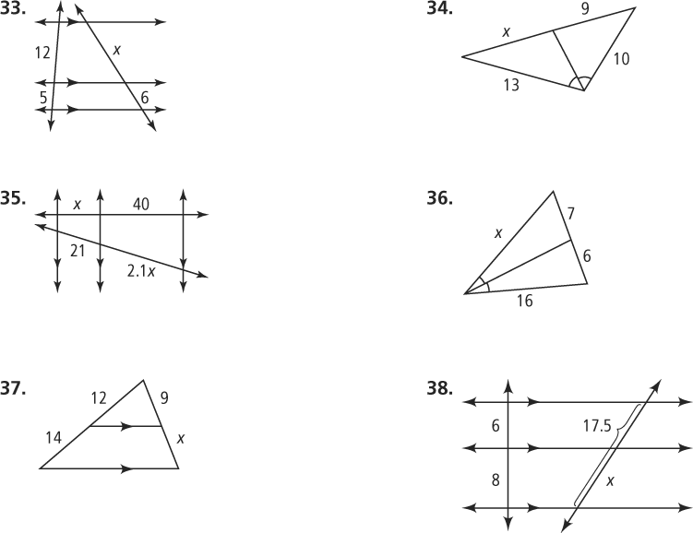**33. 34.**

**35. 36.**

**37. 38.**

**Prentice Hall Geometry •** Extra Practice

Copyright © by Pearson Education, Inc., or its affiliates. All Rights Reserved.

**25**

Name

Class

Date

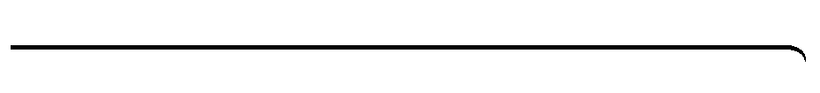

**Extra Practice** (continued)

Chapter 7

**39.** Suppose you are given a segment  of length 1 unit and a segment  of length *x* units. Show how you can apply the Side-Splitter Theorem to construct a segment of length 

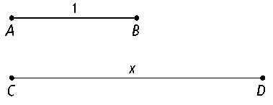

**40.** The figure below shows the locations of a high school, a computer store, a library, and a convention center. The street along which the computer store and library are located bisects the obtuse angle formed by two of the other streets. Use the information in the figure to find the distance from the library to the convention center.

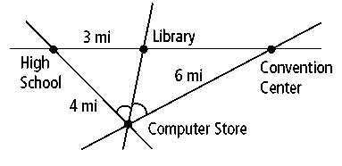

**Prentice Hall Geometry •** Extra Practice

Copyright © by Pearson Education, Inc., or its affiliates. All Rights Reserved.

**26**