Name:

LESSON

1-1

Understanding Points, Lines, and Planes

Use the figure for Exercises 1–3.

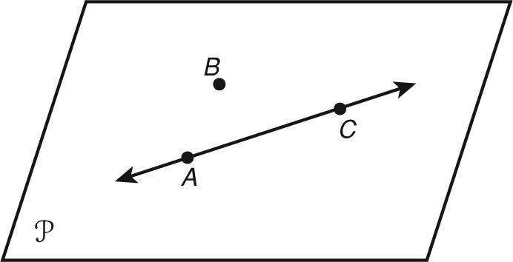 1. Name two points that determine line 

2. Are points A, B and C collinear or non-collinear?

3. Name the points that determine plane ABC.

4. Two points determine one .

5. Collinear points lie on the same .

6. Three non-collinear points determine a .

7. Any three points are always .

Use the figure for Exercises 8–10.

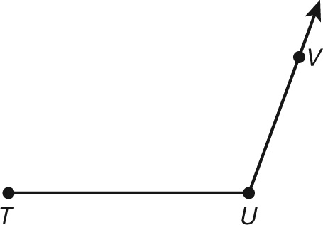 8. A line segment is a part of a line and has two endpoints.   
Name the endpoints of 

9. Find the number of endpoints of  _________________

10. A ray is a part of a line that has one endpoint. Name the endpoint of $\vec{UV}$. __________

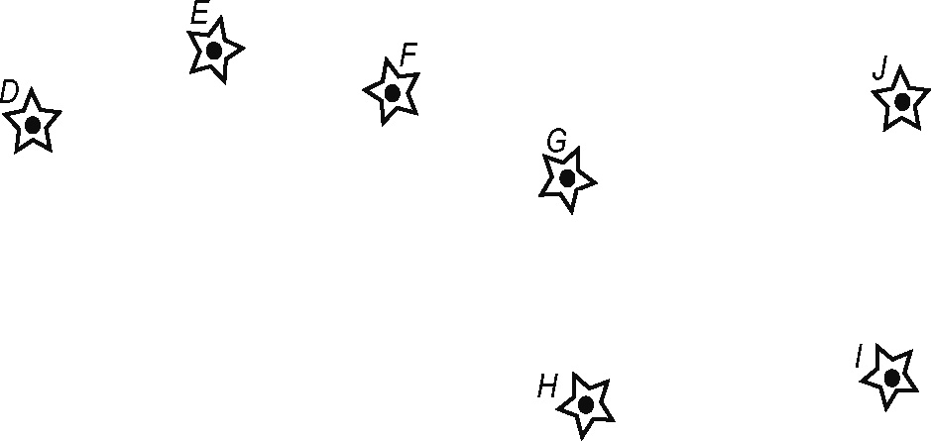 11. A constellation is a group of stars that   
people use to make a picture. The   
seven stars make the Big Dipper.   
Draw   
and  to complete the picture.

12. Draw a ray with an endpoint at point A

and it passes through point B.