Name: ___________________________ STAT 110 Practice Final Exam

- Explain how the variable “test grade” could be measures as both a categorical variable and a quantitative variable. (2 pts)

- If you are dealing with quantitative data what are two ways to graphically represent your data? (2 pts)

- Based on the histogram shown answer (T/F) for each statement below:

(1 pt. each)
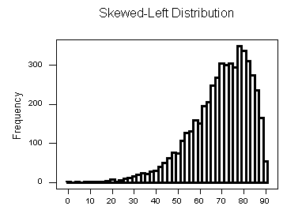

  - The mean is less than the median. _____

  - The Standard Deviation is the best measure of spread. _____

  - The distribution is symmetrical. _____

  - The data represented is categorical data. _____

  - The graph is a histogram. _____

- If the mean score on a test was a 71% and the standard deviation was 8%, what would be the approximate score of someone in the 80th percentile? (4 pts)

- What is the probability that if you randomly select a letter from the word “STATISTICS” and then roll a 6-sided die, that you get a vowel and a number greater than 3? (3 pts)

- You got an 82% on a math test where the class average was a 77% and the standard deviation was a 3%, and then you got a 79% on a science test where the class average was a 71% with a standard deviation of 4%.
  - Using Z-scores which class did you do better in compared to the rest of the class? (3 pts)

  - What was your percentile ranking in each class? (2pts)

  - In your math class approximately what percent of people scored between a 70% and an 82%? (3 pts)

- Given the summary of a data set gives the following values:
Mean = 23, Median = 30, Min = 9, Q1 = 24, Q3 = 34, Max = 40

- Show if any numbers are outliers (3 pts)

- Would the distribution be skewed left, right, or symmetric based on the values you are given above? (Support your answer) (2 pts)

- At a school there are 100 students in the Senior Class and: 8 Students play Baseball, Basketball and Football
15 Students play Baseball and Football
17 Students play Baseball and Basketball
14 Students play Basketball and Football
31 Students play Baseball
36 Students play Football
30 Students play Basketball
- Draw a Venn diagram to represent this scenario, make sure to include students that do not play any sports. (3 pts)

- What is the probability someone plays football? What is the probability that someone plays football given they also play baseball? (2 pts)

- What is the probability that you randomly select one student and they do not play any of these sports? (2 pts)

- What is the probability that if you select two students, they both play all three sports? (2 pts)
FOR PROBLEM 9 CONDUCT THE APPROPRIATE HYPOTHESIS TEST AND MAKE SURE TO INCLUDE ALL NECCESARRY PARTS OF THE TEST (10 pts each)

9) A professor tells the class on the first day that the distribution for grades in all his classes over the past 20 years, has been as shown:
21% A’s, 32% B’s, 25% C’s, 14% D’s, and 8% F’s
At the end of the semester the class of 40 students feels the professor was lying to them when he originally told them his normal break down of grades since out of the 40 students there were 7 A’s, 10 B’s, 14 C’s, 4 D’s and 5 F’s. Does this data support the class’s claim that the professor was probably lying to them at the beginning of the semester? (Assume students were randomly selected)

- Sara is taking a test in her science class and her math class, if the class average in science was a 72% and the standard deviation was 8%, compared to an average of 78% and a standard deviation of 2% in her math class. Which tests did she do better on compared to the rest of the class given her score on the science test was a 90% and the math test score was an 83%? (Explain)

- If mean of a population that is normally distributed is 20 and the standard deviation of the population is 4. Sketch the normal distribution for the population and clearly label the percentages within each set of standard deviations. (4 pts)

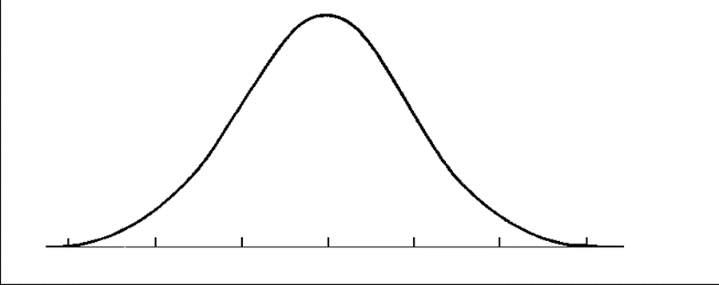

12) If someone believes the average temperature in a specific state is over 81º and they take a sample of 40 days and record the temperatures for that state. The average temperature for the 40 days is 83º. They conduct an appropriate hypothesis test and discover the p-value is equal to 0.04. Explain in detail what the p-value is saying in the context of this problem.

13) A publishing company pays its sales staff $600 a week plus commission of $0.50 per book sold. For example, a salesman who sold 440 books last week earned $600 + $0.50(440) = $820

Statistic | Books Sold | $ Earned
Mean | 640
Standard Deviation | 360
IQR | 450
Maximum | 1420

- Fill in the table above to show the statistics for the pay these people earned.

- Using the mean and standard deviation calculated in part A find the Z-score for someone who earned $1170.

14) A roadway construction process uses a machine that pours concrete onto the roadway and measures the thickness of the concrete so the roadway will measure up to the required depth in inches. The concrete thickness needs to be consistent across the road, but the machine isn’t perfect, and it is costly to operate. Since there’s a safety hazard if the roadway is thinner than the minimum 23-inch thickness, the company sets the machine to average 26 inches for the batches of concrete. They believe the thickness level of the machine’s concrete output can be described by a normal model with a standard deviation of 1.75 inches. [Show all work]

a. What percent of the concrete roadway is under the minimum depth?

b. The company’s lawyers insist that no more than 3% of the output be
under the limit. Because of the expense of operating the machine, they cannot afford to reset the mean to a higher value. Instead, they try and reduce the standard deviation to achieve the “only 3% under” goal. What standard deviation must they attain to reach the goal?
15) Using the table shown for Hours worked and # of products sold, answer the following three questions.

a) What is the equation for the linear regression line to predict products sold based on the number of hours worked?
Hours | # Sold
2 | 18
5 | 22
7 | 38
9 | 54
12 | 72

b) What type of correlation does the data show?

c) Using your prediction equation, how many products sold would you predict for someone who worked 7 hours?

d) What is the residual for someone who worked 9 hours?

16) Owners of an exercise gym believe that a normal model is useful in projecting the number of clients who will exercise in their gym each week. They use a mean of 800 clients and a standard deviation of 90 clients.

a. Draw and clearly label this model below:

b. Find the value of the 75th percentile in the distribution above?

c. What is the probability that for one month picked at random the number of clients that use the gym is OVER 950?

17) You have a bag with 10 number tiles in it and the tiles are numbered from 1 – 10. You are going to select a tile and then record the number, then put the tile back in the bag and repeat the process. What is the probability that if you select 250 tiles you would get at least 134 odd numbered tiles?

