Name: Math 153 Test #2

1. Describe the difference between a parameter and a statistics. Then draw the symbol that shows mean as a parameter and the symbol for mean as a statistic, also draw the symbol for proportion as a parameter and proportion as a statistic.
2. Which diagram shows a high variability but a low bias?

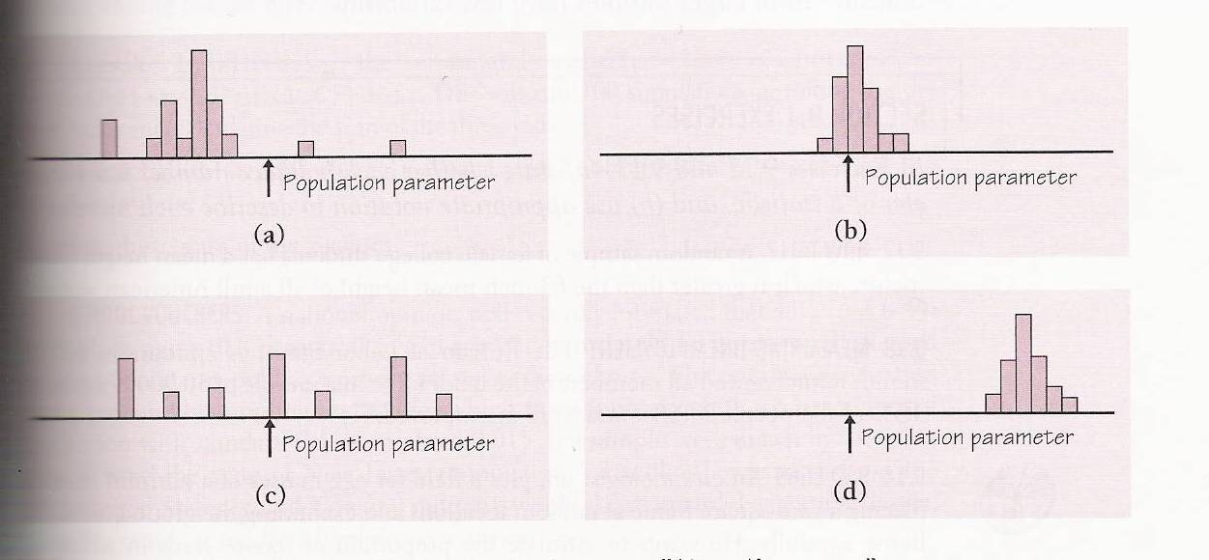

1. If out of 100 students surveyed at a school 46 of them said they like to watch the T.V show “Big Brother” what would be the value of p-hat, and is p-hat a statistic or a parameter?
2. Using the information from problem #3 what would be the approximate value of p and what would be the standard error of our sampling distribution for sample proportions? (Assume conditions are met)
3. An SRS of 1000 first-year college students were asked whether they applied for admission to any other college. In fact, 47% of all first-year students applied to colleges beside the one they are attending.

What is the probability that the poll will be within 2 percentage points of the true p? (Between 45% and 49%)

1. A population of manufactured products where the random variable X is the weight of the item. Prior experience has shown that the weight has a normal distribution with mean 5.0 ounces and standard deviation of 2.0 ounces.
   1. What is the probability that the weight of an item randomly selected will be more than 6.5 ounces?
   2. Using proper notation, show the distribution of?
   3. What is the probability that if the manufacturer takes a random sample of 100 items, that it has a mean weight between 5.1 and 5.5 ounces?
2. What conditions must be met for us to use a normal distribution and calculate z-scores when dealing with quantitative data?
3. A company that produces light bulbs is concerned about the distribution of the life expectancy of the bulbs. The company takes a simple random sample of 100 bulbs and computes the sample mean to be 950 hours per bulb.
   1. Construct a 95% confidence interval for the unknown mean life expectancy assuming that the population standard deviation is 30 hours.
   2. Interpret the 95% confidence interval found in (a).
4. Lie detectors are based on measuring changes in the nervous system. The assumption is that lying will be reflected in physiological changes that are not under the voluntary control of the individual. When a person is telling the truth, the galvanic skin response scores have a distribution that is normal with a mean of 48.6 and a standard deviation of 4.
   1. What is the probability that a person will have a score less than 42?
   2. Suppose a simple random sample of 64 people is taken, what is the distribution of?
   3. What is the probability that the average score for the 64 people will be more than 49.4?
5. In a simple random sample of 400 students taken at a large university, 60 are math majors. (Assume conditions are met)
6. Construct an approximate 80%-confidence interval for the percent of students at the university who are math majors.
7. If you wanted to become more confident in your response without changing the sample size what would happen to your interval that you found in part a. (Explain in basic terms)
8. Using the formula for margin of error () if you wanted to have a margin of error less than 5% using a 95% confidence interval (Z-score of 1.96) and the standard deviation of the population was 40, what would be the smallest sample size you could take?
9. The actual time it takes to cook a 20 – pound turkey is a normal random variable with a mean of 4.8 hours and a standard deviation of 0.5 hours.
10. What is the probability that a randomly selected 20-pound turkey will take less than 5 hours to cook?
11. What is the probability that the average cooking time of a 20 – pound turkey will take between 4.2 and 4.9 hours to cook?
12. Given that an average of 5 hours was found for a sample of 50 turkeys, calculate a 90% confidence interval for the average cooking time of a 20 – pound turkey.
13. Interpret the interval found in (c).
14. Is the parameter that you are trying to estimate in (d) actually in the interval? What is the parameter?

FORMULAS







