Name: _________________________
- Read the sentences below and then identify each underlined (bold) number by labeling it with the proper statistical symbol.
Joe wanted to figure out the average number of T.V’s per house in Maryland. He randomly selected 50 houses from the phone book and called each one to ask them how many T.V’s they had. The average number he calculated for the people that answered the phone was 3.2 and the standard deviation was 1.3.

- If 80 students were surveyed at a school and 56 of them said they like to watch the T.V show “The Big Bang Theory” what would be the value of p-hat, and then calculate the standard error of the sampling distribution using this information?

- An SRS of 500 college students were asked whether they enjoy shopping at the mall. Somehow it is known that 54% of all college students enjoy shopping at the mall. Given that information what is the probability that the poll will be within 2 percentage points of the true p? (Between 52% and 56%)

- A population of manufactured products where the random variable X is the weight of the item. Prior experience has shown that the weight has a normal distribution with mean 16.0 ounces and standard deviation of 4.0 ounces.

  - What is the probability that the weight of a single item randomly selected will be more than 21.5 ounces?

  - What is the probability that if the manufacturer takes a sample of 100 items, that the sample has a mean weight between 16.5 and 17.0 ounces?

  - Sketch and label a normal distribution to show the sampling distribution offor the sample size of 100.

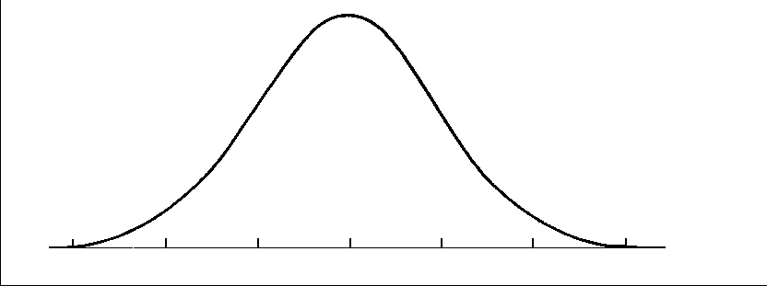

- A company that produces light bulbs is concerned about the distribution of the life expectancy of the bulbs. The company takes a simple random sample of 81 bulbs and computes the sample mean to be 950 hours per bulb. Given a population standard deviation of 20 hours answer the following questions.

  - Check the conditions to see if you can use a normal distribution?

  - What is the probability that a sample of size 60 will have an average life expectancy of over 953 hours?

- The actual time it takes to cook a 25 pound turkey is a normal random variable with a mean of 5.4 hours and a standard deviation of 0.7 hours.

- What is the probability that a sample of 30 randomly selected 25 pound turkeys will take on average less than 5.3 hours to cook?

FORMULAS
Sampling Distribution of Proportions
$$μ_{\hat{p}}=p$$
$$σ_{\hat{p}}=\sqrt{\frac{p(1-p)}{n}}$$

Sampling Distribution of Means
$$μ_{\overline{x}}=μ$$
$$σ_{\overline{x}}=\frac{σ}{\sqrt{n}}$$

